Fitness Center & Gym Membership Management
A MySQL-based CRM / Transaction Processing System with Decision Support Output

Submitted by: Harikrishnan M, Malavika H and Mathew Justin Reg No: P03HB25M015123, P03HB25M015127 and P03HB25M015110
Course / Class: MBA-B Submitted to: Dr. Mrinmoy Roy

Introduction
A gym has to keep track of many things every day: who has joined, who has paid, which trainer is working with which member, and who actually comes to train. When this is done on paper or in separate spreadsheets, mistakes happen and the owner cannot easily see how the business is doing.
This project builds a small database system for a fitness center using MySQL. It stores member, trainer, subscription and entry information in four connected tables. On top of this data, the system produces two reports that help the owner make decisions: the ratio of active to inactive members, and how busy each trainer is.

Objectives
- To store gym member, trainer, subscription and access (entry/exit) records in an organised MySQL database.
- To make sure only members with a valid, paid subscription can enter the gym.
- To find out how many members are active and how many are inactive.
- To measure how well each trainer is being used.
- To help the manager take decisions such as running renewal offers or balancing trainer workload.

Type of System

CRM (Customer Relationship Management)
The system keeps member details and subscription history so the gym can stay in touch with its customers. For example, the view vw_expiring_soon lists members whose plan ends within 7 days, and vw_renewal_leads lists inactive members who can be contacted for renewal.

TPS (Transaction Processing System)
Daily operations such as registering a member, recording a payment and logging a check-in are transactions. The stored procedure sp_check_in checks the member's subscription first and only then records the entry. If the subscription is not valid, the transaction is rolled back and an "Access denied" message is shown.

DSS (Decision Support System) output
The data collected by the TPS is summarised into two reports for the manager: Active vs Inactive ratio and Trainer Utilization.

Data Flow Diagram (Level 1)
The Level 1 DFD, drawn in Draw.io, shows the main processes of the system, the people who use it, and the tables where data is stored.
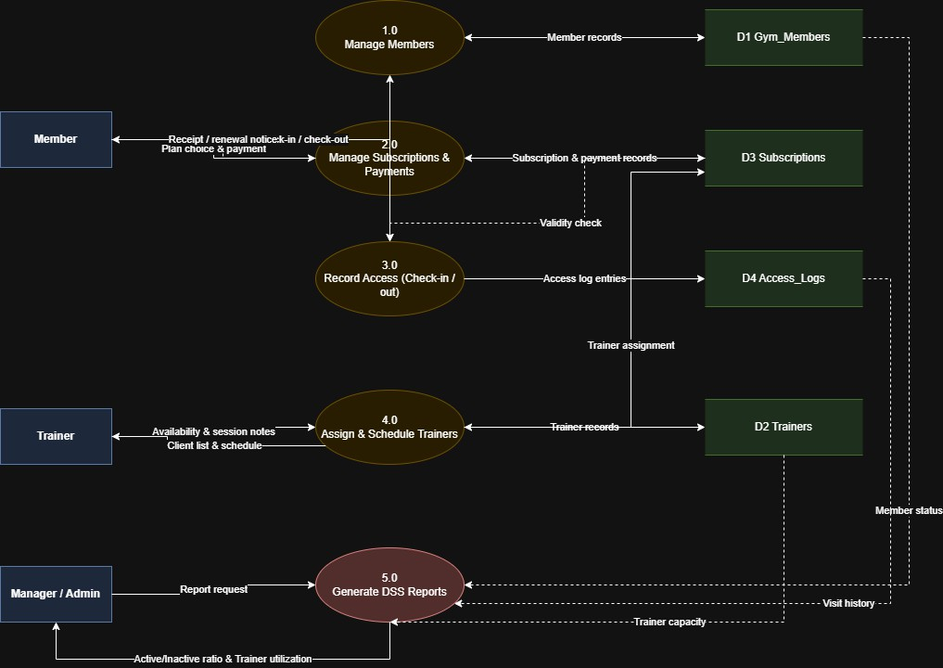
Figure 1: DFD Level 1 – Gym Management System

External entities
- Member gives registration details, chooses and pays for a plan, and checks in or out.
- Trainer gives availability and session notes, and receives the client list and schedule.
- Manager / Admin requests reports and receives the DSS results.

Processes

No. | Process | What it does
1.0 | Manage Members | Adds and updates member records in Gym_Members.
2.0 | Manage Subscriptions & Payments | Creates plans, records payments, and sends receipt or renewal notices.
3.0 | Record Access | Checks the subscription and records check-in and check-out in Access_Logs.

No. | Process | What it does
4.0 | Assign & Schedule Trainers | Links trainers to members and keeps trainer records in Trainers.
5.0 | Generate DSS Reports | Reads all data stores to produce the Active/Inactive ratio and Trainer Utilization.

Data stores
D1 Gym_Members, D2 Trainers, D3 Subscriptions and D4 Access_Logs.

Database Design

Tables and relationships

Table | Purpose | Key links
Gym_Members | Member profile and Active/Inactive status | Primary key: member_id
Trainers | Trainer details and weekly session capacity | Primary key: trainer_id
Subscriptions | Plan, dates, amount and payment status | Foreign keys: member_id, trainer_id
Access_Logs | Every check-in and check-out | Foreign keys: member_id, trainer_id

One member can have many subscriptions and many access log entries. One trainer can be linked to many subscriptions and many training sessions. These are one-to-many relationships, created with foreign keys.

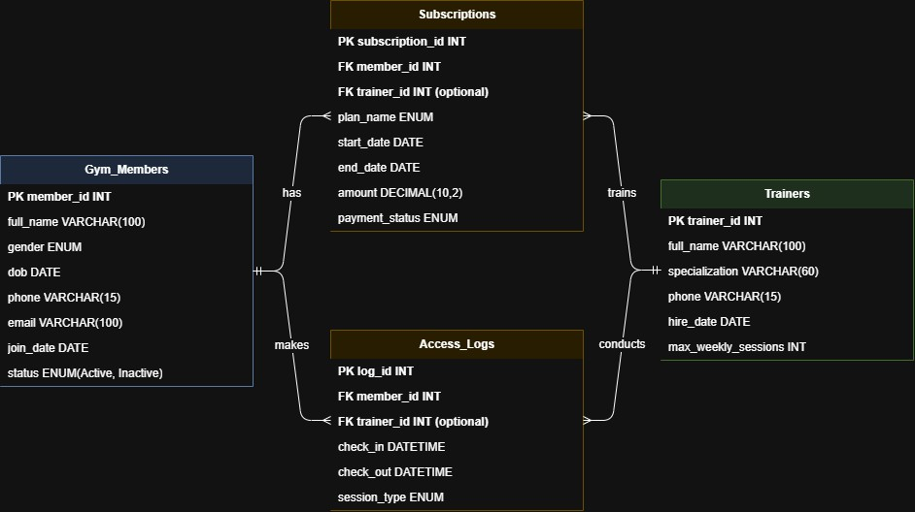
Figure 2: ER Diagram
  - Data dictionary Gym_Members
Field | Data type | Description
member_id | INT, PK, auto | Unique ID of the member
full_name | VARCHAR(100) | Member's name
gender | ENUM | Male / Female / Other
dob | DATE | Date of birth
phone | VARCHAR(15) | Contact number
email | VARCHAR(100), unique | Email address
join_date | DATE | Date the member joined
status | ENUM | Active or Inactive

Trainers

Field | Data type | Description
trainer_id | INT, PK, auto | Unique ID of the trainer
full_name | VARCHAR(100) | Trainer's name
specialization | VARCHAR(60) | Area of expertise

Field | Data type | Description
phone | VARCHAR(15) | Contact number
hire_date | DATE | Date of joining
max_weekly_sessions | INT | Maximum training sessions the trainer can handle per week

Subscriptions

Field | Data type | Description
subscription_id | INT, PK, auto | Unique ID of the subscription
member_id | INT, FK | Member who bought the plan
trainer_id | INT, FK, optional | Personal trainer assigned, if any
plan_name | ENUM | Monthly / Quarterly / Yearly
start_date, end_date | DATE | Validity period of the plan
amount | DECIMAL(10,2) | Amount paid
payment_status | ENUM | Paid / Pending / Failed

Access_Logs

Field | Data type | Description
log_id | INT, PK, auto | Unique ID of the entry
member_id | INT, FK | Member who entered
trainer_id | INT, FK, optional | Trainer for personal training sessions
check_in | DATETIME | Time of entry
check_out | DATETIME | Time of exit
session_type | ENUM | Gym Floor / Personal Training / Class

SQL Implementation
The complete script (gym_management.sql) creates the database gym_db, the four tables, sample data, stored procedures and views. The important parts are shown below.

Check-in transaction (TPS)
This procedure allows entry only when the member has a paid subscription that covers today's date.
CREATE PROCEDURE sp_check_in(IN p_member_id INT,
IN p_trainer_id INT, IN p_type VARCHAR(20))

BEGIN
DECLARE v_valid INT DEFAULT 0; START TRANSACTION;
SELECT COUNT(*) INTO v_valid FROM Subscriptions
WHERE member_id = p_member_id AND payment_status = 'Paid' AND CURDATE() BETWEEN start_date AND end_date;
IF v_valid = 0 THEN SIGNAL SQLSTATE '45000'
SET MESSAGE_TEXT = 'Access denied: no active paid subscription'; END IF;
INSERT INTO Access_Logs (member_id, trainer_id, check_in, session_type) VALUES (p_member_id, p_trainer_id, NOW(), p_type);
COMMIT;
END

Active vs Inactive view (DSS)

A member is Active if they have a paid subscription covering today. Otherwise the member is Inactive.

CREATE VIEW vw_active_inactive_ratio AS SELECT status, COUNT(*) AS total_members,
ROUND(COUNT(*) * 100.0 / (SELECT COUNT(*) FROM Gym_Members), 2) AS percentage FROM Gym_Members GROUP BY status;

Trainer Utilization view (DSS)

Utilization = personal training sessions in the last 30 days ÷ capacity, where capacity = max_weekly_sessions × 4. A trainer at 80% or above is labelled Overloaded, 40–79% Optimal, and below 40% Under-utilised.

CREATE VIEW vw_trainer_utilization AS
SELECT t.trainer_id, t.full_name AS trainer, t.specialization, COUNT(a.log_id) AS sessions_last_30d,
t.max_weekly_sessions * 4 AS capacity_30d,
ROUND(COUNT(a.log_id) * 100.0 / (t.max_weekly_sessions * 4), 1) AS utilization_pct FROM Trainers t LEFT JOIN Access_Logs a
ON a.trainer_id = t.trainer_id AND a.session_type = 'Personal Training'
AND a.check_in >= DATE_SUB(NOW(), INTERVAL 30 DAY)
GROUP BY t.trainer_id, t.full_name, t.specialization, t.max_weekly_sessions;

Results and Analysis

Active vs Inactive members

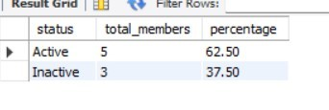
SELECT * FROM vw_active_inactive_ratio;
Figure 3: Active vs Inactive members

Status | Members | Percentage
Active | 5 | 62.5%
Inactive | 3 | 37.5%

Out of 8 members, 5 (62.5%) are active and 3 (37.5%) are inactive. The inactive members have expired subscriptions, so the gym should contact them with renewal offers.

Trainer Utilization

SELECT * FROM vw_trainer_utilization;

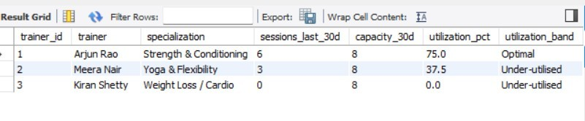
Fig
ure 4: Trainer Utilization

Trainer | Sessions (30 days) | Capacity | Utilization | Status
Arjun Rao | 6 | 8 | 75% | Optimal
Meera Nair | 3 | 8 | 37.5% | Under-utilised
Kiran Shetty | 0 | 8 | 0% | Under-utilised
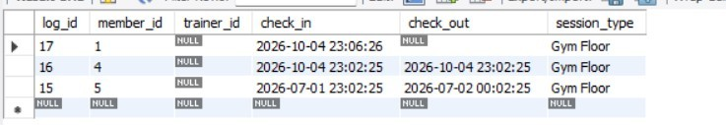
Arjun Rao is the busiest trainer at 75% utilization and is working at a healthy level. Meera Nair (37.5%) and Kiran Shetty (0%) are under-utilised. The manager can assign new members to them or promote their services to balance the workload.

Check-in validation test (TPS)
CALL sp_check_in(5, NULL, 'Gym Floor');

Figure 5: Check-in rejected for a member with an expired plan

    - Member 1 has an active paid subscription, so the check-in was recorded in Access_Logs
      - Member 5 has an expired subscription, so the system rejected the entry and no record was added to Access_Logs. This shows that the transaction checks the data before saving it.

How the Manager Can Use These Results
- High inactive percentage: Run a renewal campaign for the inactive members and call those whose plan is about to expire.
- Low trainer utilization: Assign new members to under-utilised trainers or advertise their classes.
- Overloaded trainer: Hire another trainer or limit new bookings for that trainer.

Conclusion
This project created a working MySQL database for a fitness center with four connected tables. It records daily transactions, checks subscriptions before allowing entry, and gives the manager two useful reports: the Active vs Inactive ratio and Trainer Utilization. The results show that 62.5% of members are active and that trainer workload is uneven, which supports clear management decisions.

Future work
- A dashboard in Power BI or Python to show the reports as charts.
- A web or mobile front-end for the reception desk.
- Automatic SMS or email reminders before a subscription expires.
- Peak-hour analysis and revenue reports by plan type.
- ​

Tools Used
- MySQL Server and MySQL Workbench – database and SQL
- Draw.io (diagrams.net) – DFD Level 1
- Microsoft Word – report

